**Assignment 3 – Lending Club**

**Team 4 - Pip the Borrower (Bad credit)**

**What is Peer to Peer Lending?**

-lending money via online services

-lending to anonymous lenders with borrowers

-lenders receive higher returns

**What are the Risks?**

-risk with borrowers to default the loan

**How are the interest rates set to borrowers with bad credit?**

Interest rates for borrowers set based on credit

-FICO score

-Employment status

-Annual income

-debt to income ratio

-number of open credit lines

**Which industries provide these services?**

Two giants in US - Lending club and prosper

**What are the interest rates and default rates?**

Interest rates - 6.7% to 22.8%

Borrowers default rates - 1.3% to 10.6%

**About Lending Club:**

-Lending Club gives 1000$ to 40000$ for 36 to 60 months

-Borrowers are graded between A to G alphabetically

-A is the safest and G is the riskiest borrower

-Loan is split into multiples of 25$ notes

-Safer the loan, lower the interest rates

**Insights from the charts:**

**Chart -1**

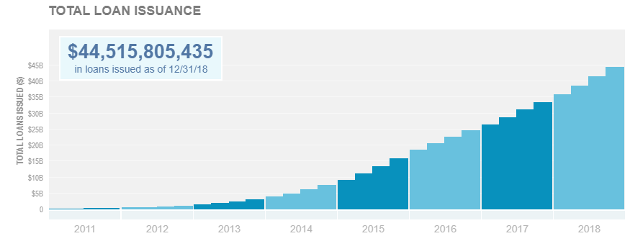

**Insights:**

* There is always an increase in total amount of loan issued every quarter of each year
* Number of loans also increases every quarter of every year

**Chart -2**

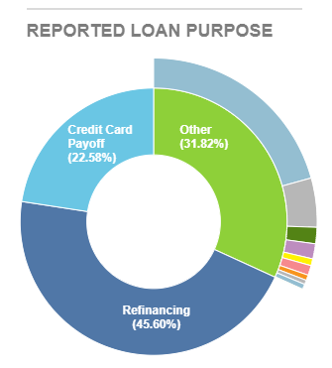

**Insights:**

* **Borrowers need for loan:**

45.6% refinancing

22.58% credit card payoff

4.85% home improvement

1.62% car financing

1.49% major purchase

0.68% business

0.97% medical expenses

0.53% home buying

0.42% moving and relocation

0.52% vacation

0.05% green loan

20.70% other loan

* Most of the borrowers use loan for refinancing followed by credit card payoff
* least used for green loan
* Client with bad credit will try to refinancing to reduce high interest rates

**Chart -3**

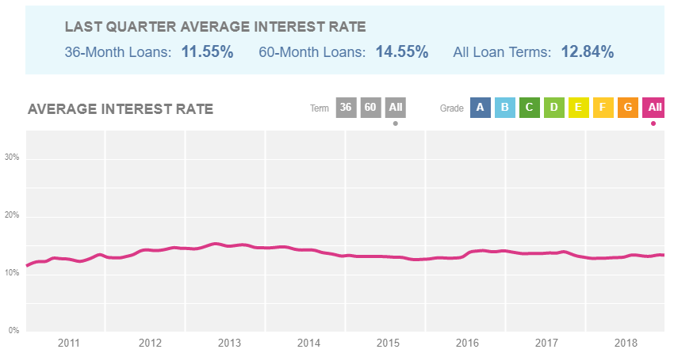

**Insights:**

* Better the grades, lower the interest rates
* Very marginal increase in interest rates with respect to duration period
* Client with a bad credit will have high interest rates

**Chart -4**

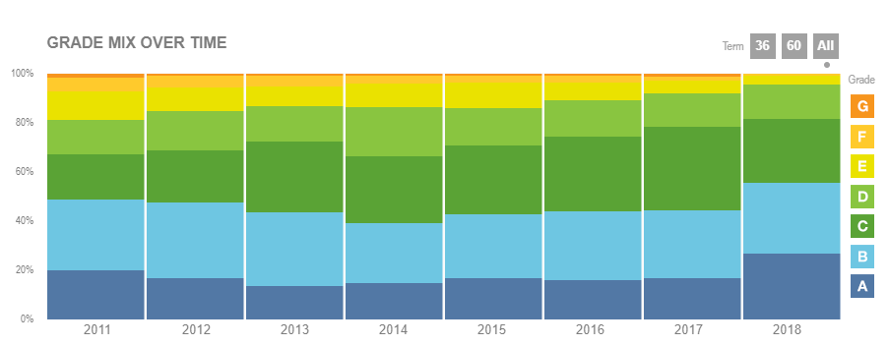

**Insights:**

* Over the period from 2011 to 2018 grade F and G have almost become negligible
* In 2018 Grade A, B, C are almost equal
* Group D has always been constant over the period
* Group E also significantly reduced from 13% in 2011 to 3% in 2018

**Chart -5**

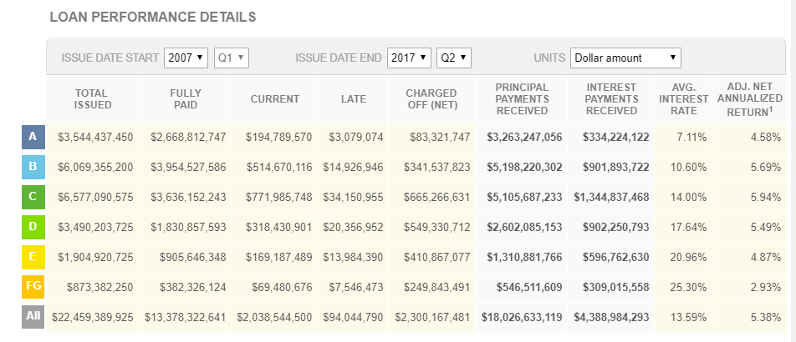

**Insights:**

* In 2007 🡪 most loan issued to Group C and least issued to Group A
* In 2018 🡪 most loan issued to Group B and least issued to Group FG
* For last 5 years Group C has been issued the more loans and Group FG has been reducing

**Chart -6**

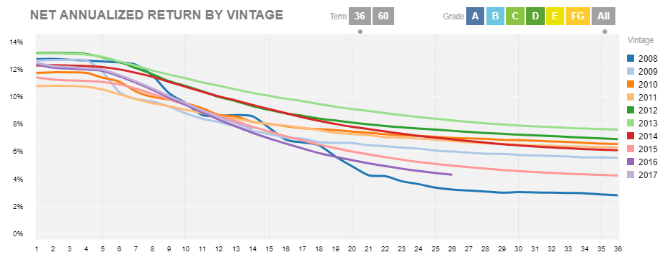

**Insights:**

* In 36 month period in first 5 months higher % of return and gradually it reduces and never gets higher
* Returns from Group A, B, C, D gets lower every month gradually, but in grades E, F, G there is a very drastic reduction after 5 months
* Returns increase from Group A to G, that is 8.5% to 35%
* As every year moves ahead, the return goes to 0% faster

**Summary:**

* Client with bad credits will be mostly categorized in grades E, F and G
* They will consider to be unsafe or risky borrowers because of bad credit
* Interest rates would be higher for these clients
* Initial percentage return of investments for investors from these clients will be higher
* Total loan amount issued to these clients for past few years have been lesser compared to other grades